Exercise 3 Solution

Tasks 1-4
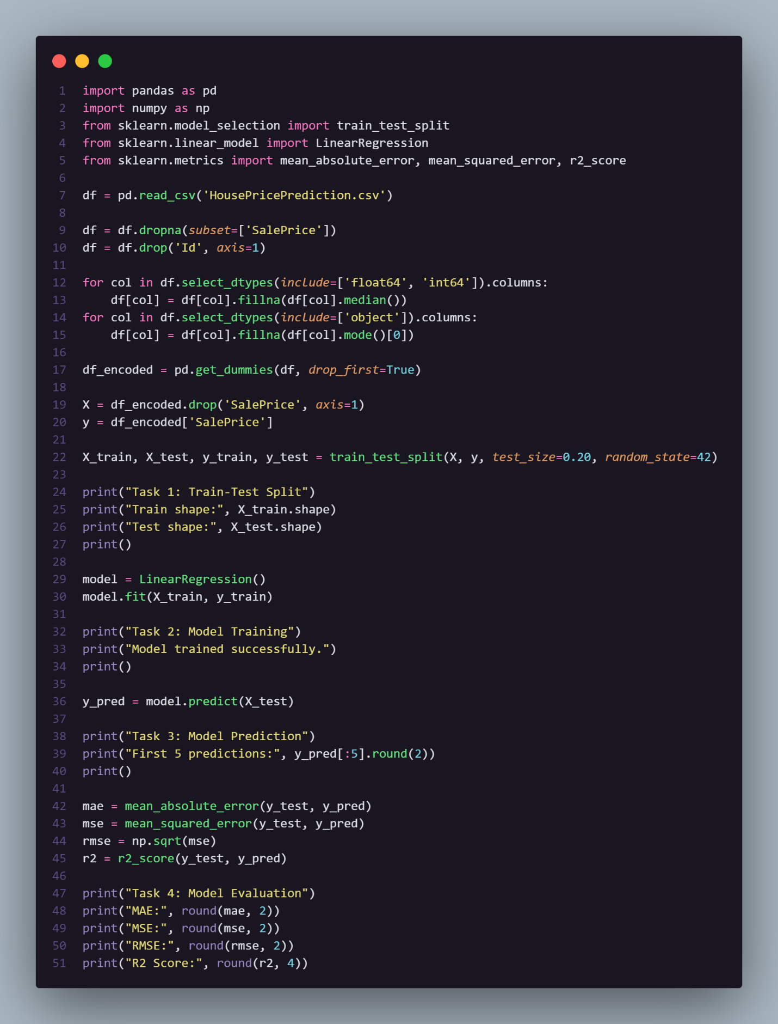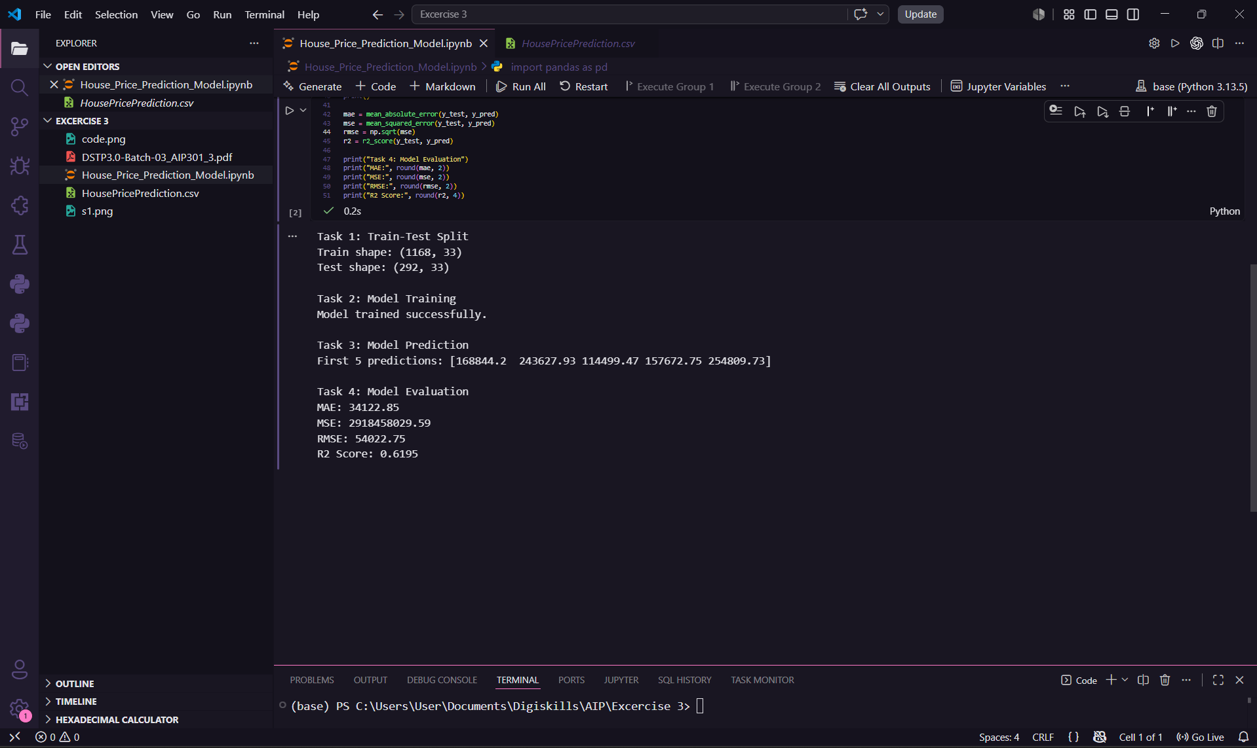

Task 5

The model has an $R^{2}$ Score of 0.6195, which means it can explain about 62% of the house prices based on the data. However, the model is not very accurate and needs improvement. The RMSE is very high at 54,022.75, meaning our predictions are off by an average of around $54,022. Since a simple Linear Regression is making large errors, we need to improve the data cleaning or try a better machine learning model to get more accurate predictions.

